**Sales Analysis Methodology**

Name: Katleho Esther Makoane

Assessment: Sales Methodology

the methodology applied in this sales analysis project for brightlight involved a structured data-driven approach, combining descriptive analytics, profitability metrics, and promotion effectiveness assessment. the process was executed using microsoft excel, snowflake sql, and powerbi to ensure a comprehensive, multi-platform analysis.

1. Data Preparation

The dataset provided (Sales Case Study) included daily transaction data for a single product over a one year period. It contained the following raw fields:

* Date
* Sales(total revenue)
* Cost of sales
* Quantity sold

Data cleansing and validation steps included:

* Parsing and formatting the data column
* Checking for missing or zero values
* Standardizing field names for consistency

1. Feature engineering & Calculated Metrics

Several derived metrics were created to support financial and demand-based analysis. These were calculated in both Excel and Snowflake SQL queries:

Unit price: Sales/quantity sold – to understand daily pricing trends.

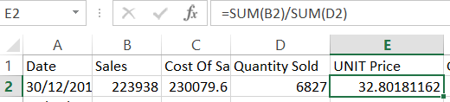

Gross Profit: Sales-Cost of sales – to measure daily profit in Rand

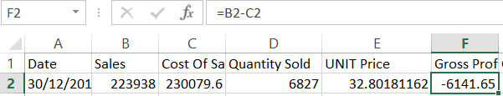

Gross Profit %: Gross Profit / sales – To assess profit margin as a percentage

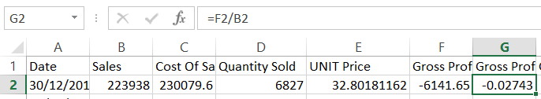

Gross Profit per unit: Gross Profit / Quantity sold - To gauge profit efficiency

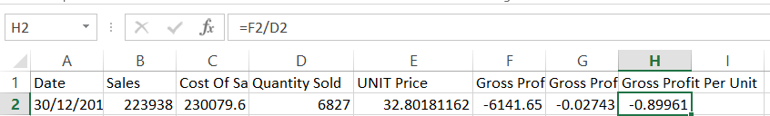

A promo flag column was created manually to mark dates (e.g. 2014-01-09, 2014-02-09, 2014-05-09) where significant price drops and volume spikes suggested promotional activity.

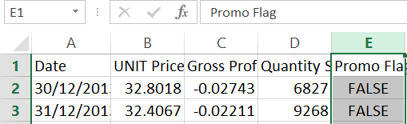

Snowflake:

Daily sales price per unit

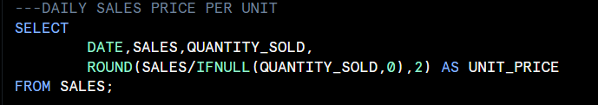

Average unit sales price

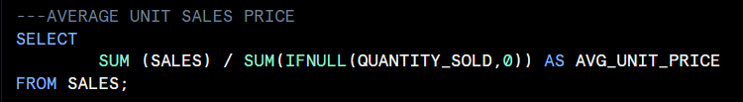

Daily & Gross Profit

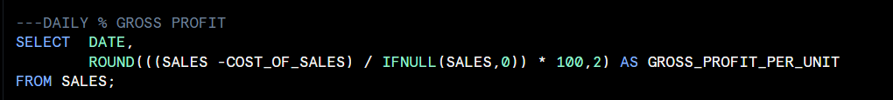

Daily % Gross Profit per unit

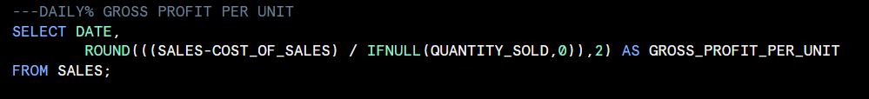

Get price and quantity for 2014-01-08 and previous day

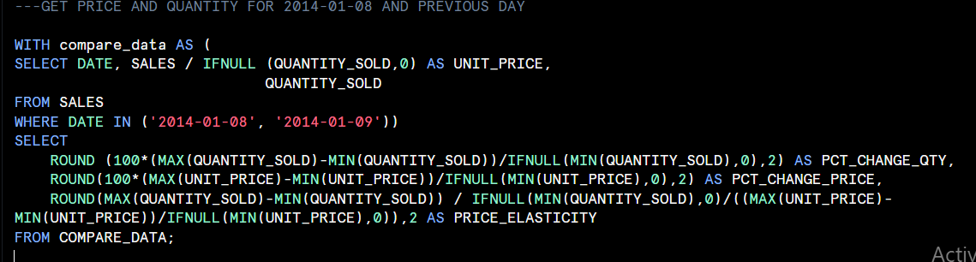

2014-02-09 PED

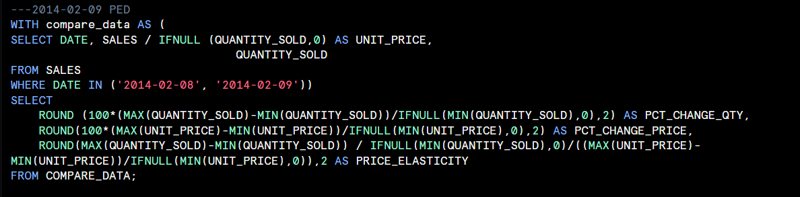

2014-05-09 PED

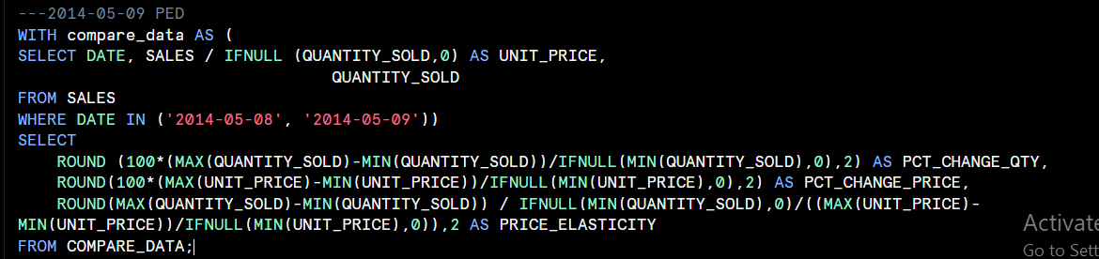

1. DESCRIPTIVE & COMPARTIVE ANALYSIS

TREND ANALYSIS

* UNIT PRICE AND GROSS PROFIT % WERE PLOTTED OVER TIME TO IDENTITFY PRICING STABILITY, SEASONAL BEHAVIOR AND PROFITABILITY TRENDS

PROMOTION ANALYSIS

* DATES WITH THE LOWEST UNIT PRICES AND HIGHEST QUANTITIES SOLD WERE FLAGGED AS PROMOTIONAL PERIODS.
* PRICE ELASTICITY OF DEMAND (PED) WAS CALCULATED FOR EACH PROMOTIONAL PERIOD TO EVALUATE HOW DEMAND CHANGED RELATIVE TO PRICE. THIS USED THE FORMULA:

PED is calculated by dividing the percentage change in quantity demanded by the percentage change in price.

Profitability Comparison

* Metrics during promo vs non-promo periods were compared to understand tradeoffs between volume and margin.

1. Visualization and Dashboard

Excel pivot tables & Charts:

* Created to show time based trends in pricing, volume and margin
* Pivot charts compared promotional and non-promotional performance

PowerBI Dashboard

* Included dynamic visualizations cards, slicers and combo charts

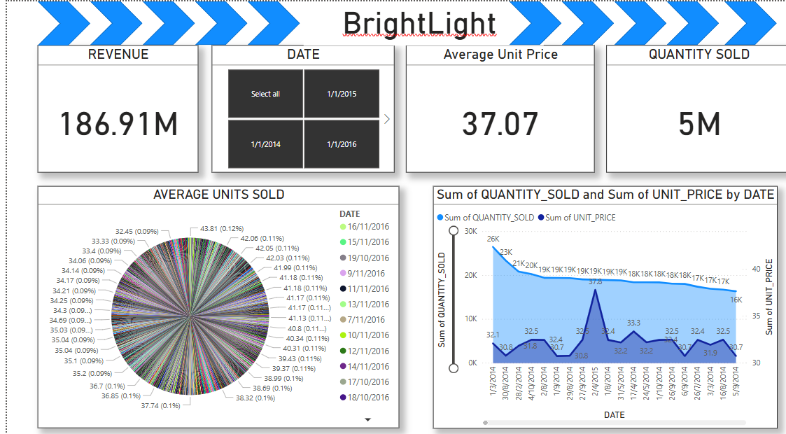

1. Insights Generation and Business Recommendations

insights were drawn by interpreting

* Demand patterns (volume response to price drops)
* Profit behavior (margin stability under discounting)
* Monthly trends(Seasonal spikes)
* Overall product elasticity

These findings formed the basis of strategic recommendations for BrightLight’s pricing and promotional planning.